Hi Clarito,

Need your help to add in Vendor name in Amtek Hub ageing report for me.
The vendor name can be find in where by the ASN rec'd ==> Carrier's reference

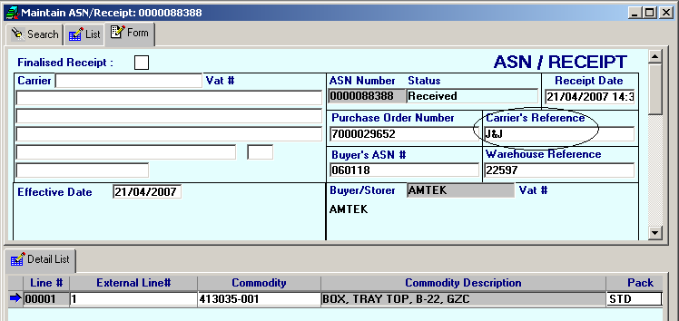

Thks & Rgds
Chee Haw
BAX Global Pte.Ltd.- HP Program
Hewlett Packard Singapore Pte Ltd
452 Alexandra Road
Singapore 119961
Tel : +65 6374 7236/7/9
Fax : +65 6270 5560
E-mail : cheehaw.song@baxglobal.com

